**Accessing Google Classroom**

Open My School [www.c2kschools.net](http://www.c2kschools.net)

Log in with your C2k username and password

*Any issues with password, please email* [*agordon646@c2kni.net*](mailto:agordon646@c2kni.net)

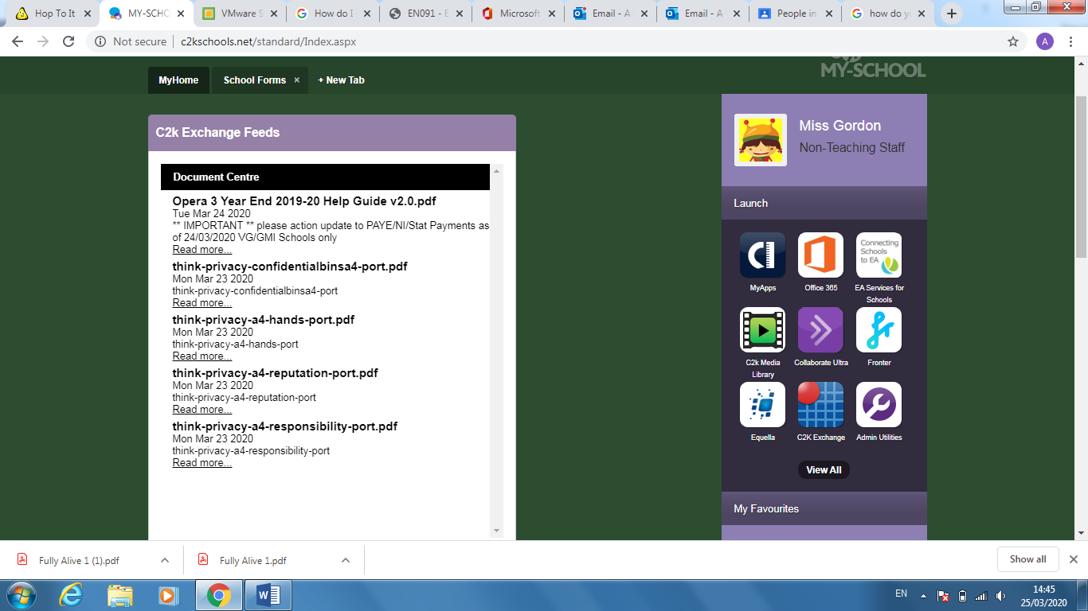

Click View All

Click G Suite for Education, then select Google Classroom

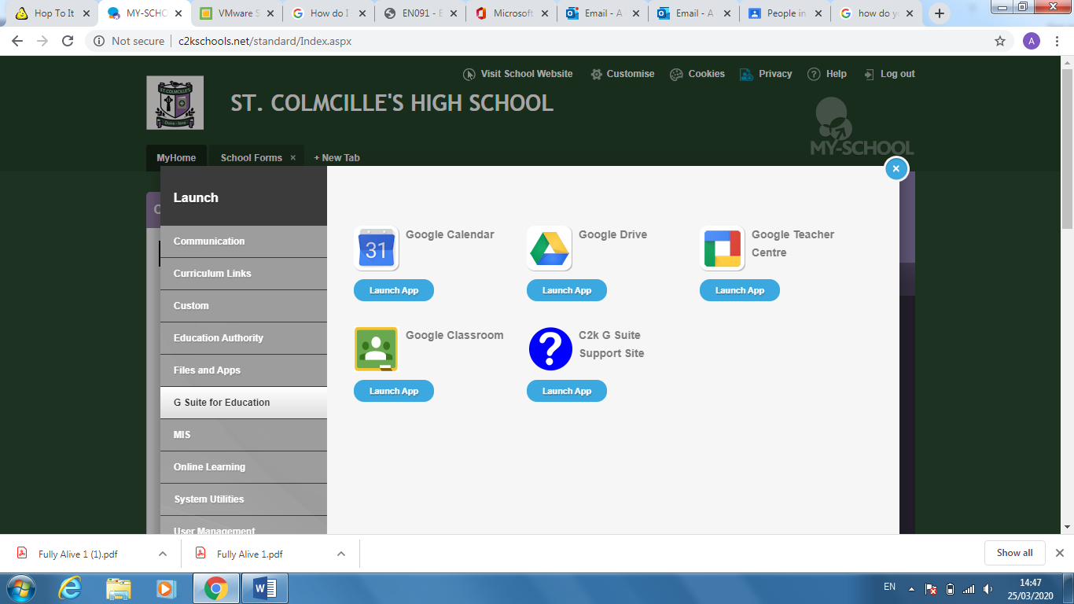

The following screen will appear, **please ensure** that when you sign in here you use your C2k [**username@c2ken.net**](mailto:username@c2ken.net) and C2k password.

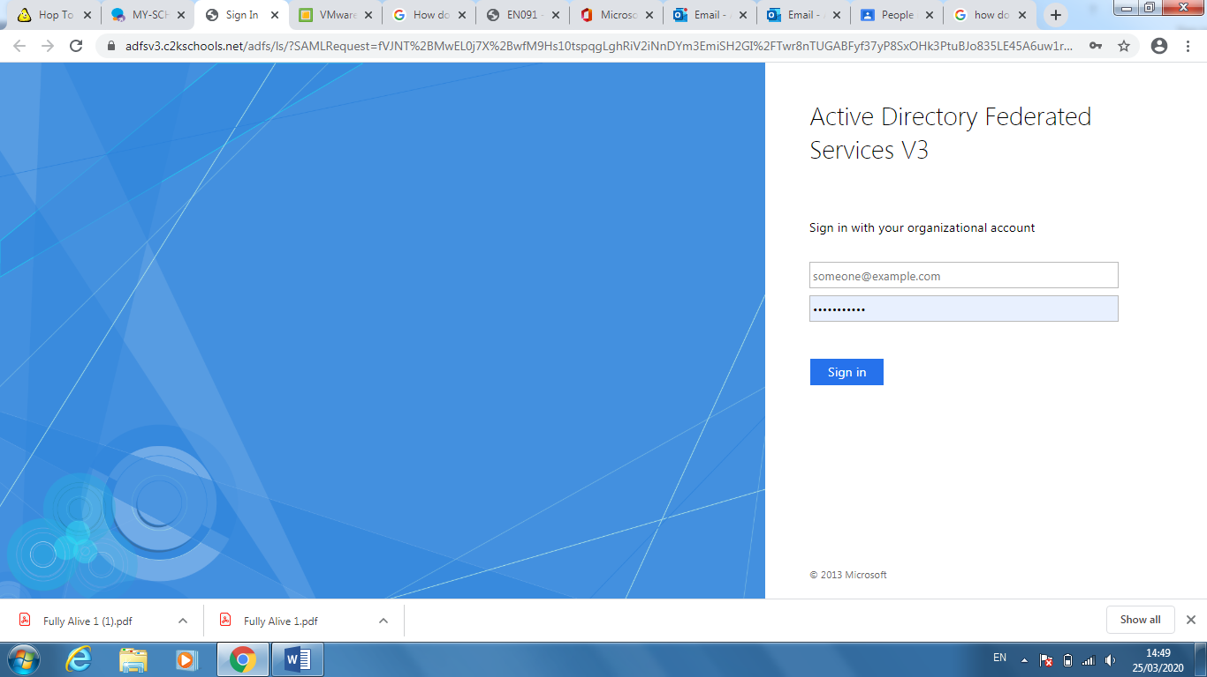

Once you have signed in, you will need to join your classes by clicking

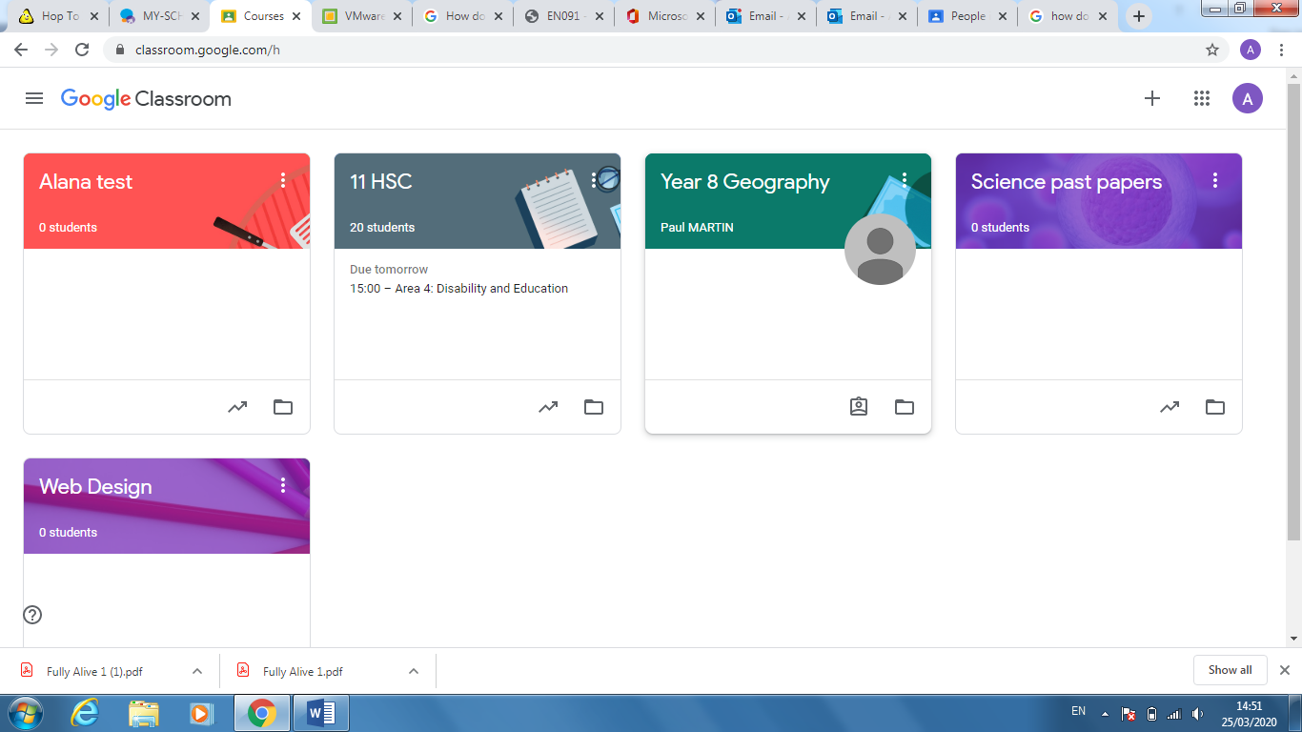

Enter the codes for your class (you can find these via the school app, under the Academic Life Section)